Operating Systems, Security and Networks 207SE Lab 4: Bootloader

# Your task

* Boot pragma Linux with bochs

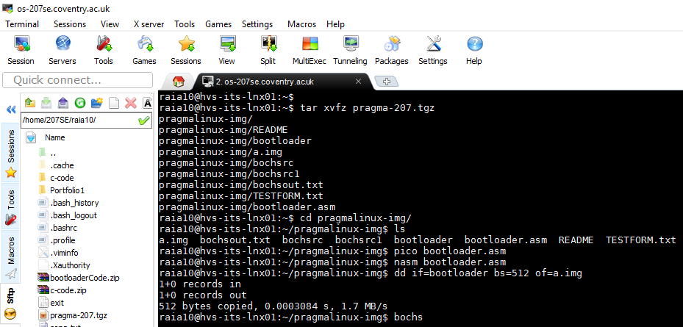

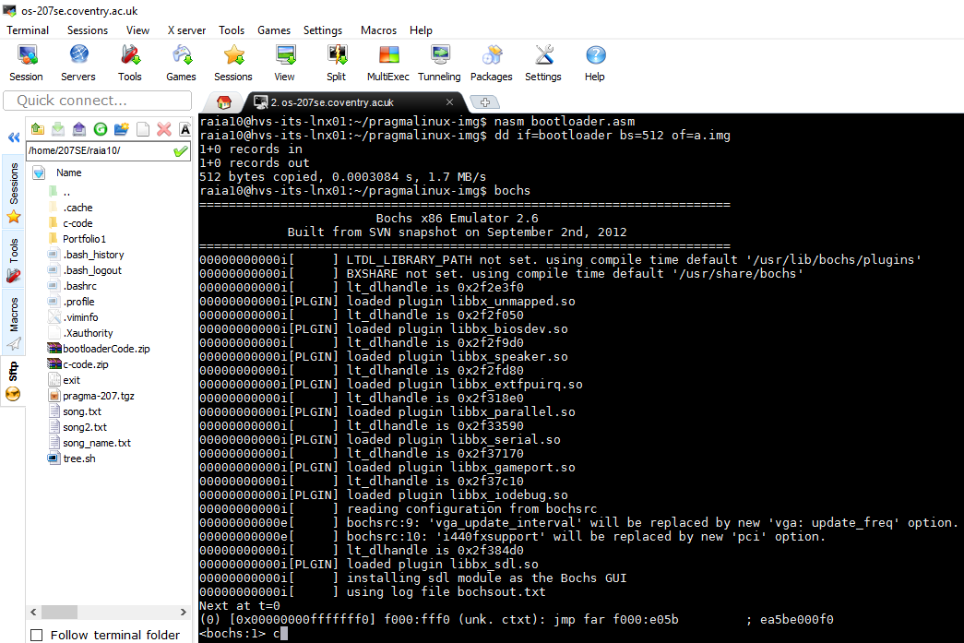

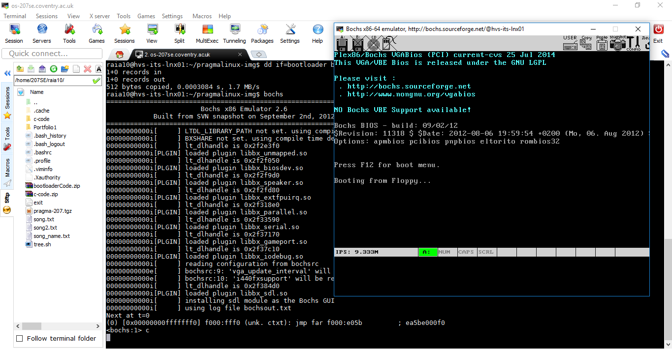

First bootloader code does nothing

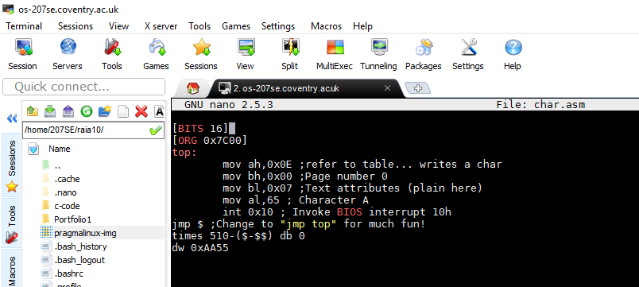

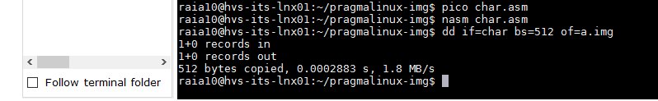

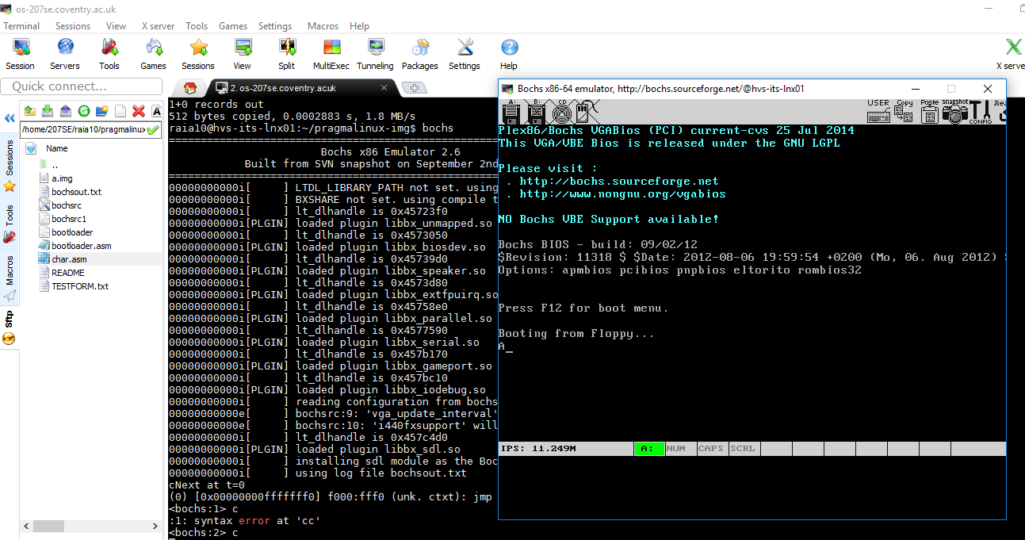

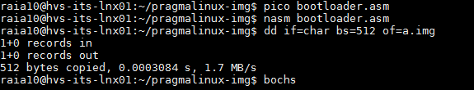

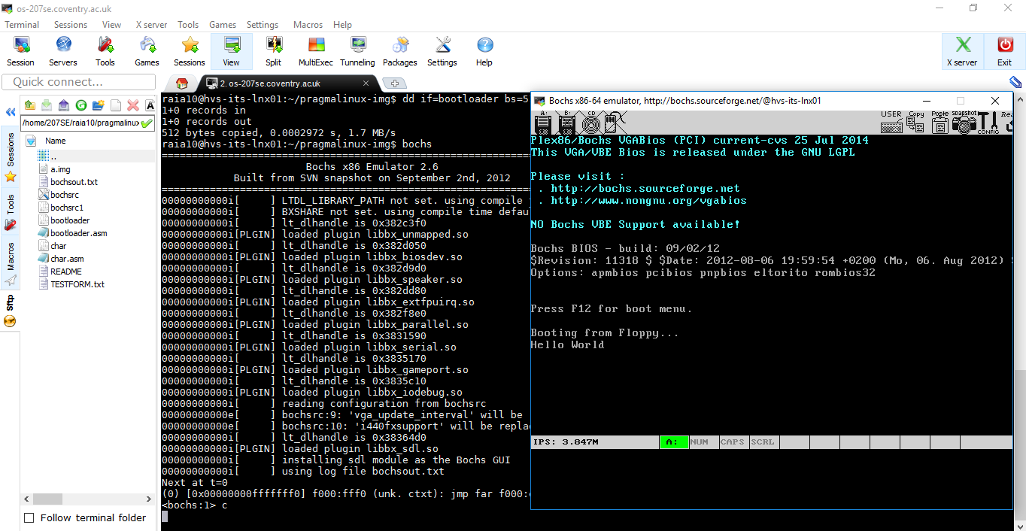

* Make a bootloader that displays your name, email address, your favourite second year module, date of birth and age. and student number on separate lines. (up to 3/5 marks)

**Screenshot the code/with comments**

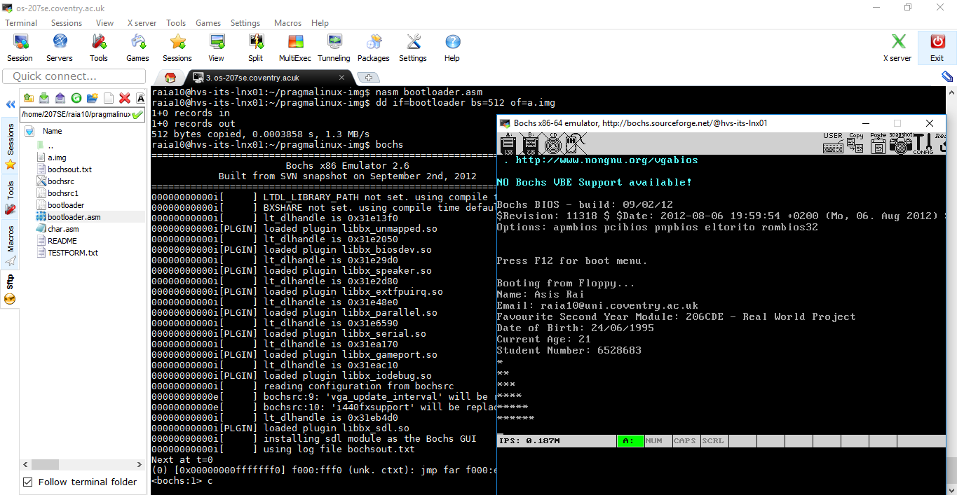

* Make a bootloader that displays a triangle of dots as well as student information (up to 5/5 marks)



# Evidence

* Screenshot of bochs running pragma linux

* Source code sensibly commented for your bootloader (triangle or student details or both together)

* Screenshot of your running bootloader showing triangle, student details or both together